- Welcome and Introductions (Jean Rikhof)
- iUnite Security – Overview of Security Measures within iUnite (Ryan Ponto)

- Encryption and Database Security
- encryption is a process that takes readable text and makes it unreadable as “cipher text”
- cipher text is sent to intended recipient (so not readable text)
- recipient has a “secret” encryption key used to interpret the cipher text
Types of encryption:
- Symmetric: when both sides use the same encryption method at the start and end
- Asyymetric: can be safer, starting encryption different from end encryption (both unique)
- Hashing: technically not encryption, a one-way transmission (hard to change cipher text back into readable data), often used for passwords (so “hashed” password is verified to be the same – but in other words the password is not known from our end)
This is what happens in our database:
- Data is encrypted as it is stored within the data (so that info pulled from a different database – not the same as where the platform information is stored)
- Data is only decrypted as there are authenticated requests
- We use these methods above to prevent physical data theft and digital data theft if the database is accessed outside of iUnite
Minimalistic Data Access:
- Database server is separate from the web server
- iUnite is granted access to the database with the fewest number of permissions possible.
- Database server can only be access with sources in the same account and region.

- Security Before Page Loads
This is when you type in the URL and you hit enter, this is what happens:
1st IP address check: All traffic must come through the firewall. Attempts to access iUnite.ca by bypassing the firewall will get a 403 error. IP is checked against known problem, block listed and allow listed IP addresses. Anyone trying to access that does not have permission to will see, “Forbidden. You don’t have permission to access this resource.”
2nd Web Application Firewall (WAF): Here are the types of attacks it prevents.
(1) DDos Protection – Dedicated Denial of Service attacks aim to overload a server or otherwise prevent normal function through traffic volume. (2) Bot Blocking – Known malicious or other suspicious bots attempting to access a website are blocked and denied all access. (3) Virtual Patching and Hardening – Attacks based on known exploits of outdated software on a server are prevented in transit to the server. (4) Geo blocking: Block or allow traffic based on its originated location. iUnite blocks all traffic outside Canada.
Question: What happens when the IP address at home is different than the IP address at work? Ryan: it is only checking if the IP address is a problem IP address.
- Securing During Page Loads
Four layers of protection before actually accessing:
- Web Application Firewall (internal)
- Automatic logout – certain sensitive pages, will log out after a certain time (each login expires after a max of 48 hours, inactive for more than an hour logs you out)
- Access Permissions – checking if you are allowed to access a page (user role checked, page/form access is checked, data access is checked before loading, DB Table access checked again before database tables are displayed)
- Automatic redirects – are based on account permissions, if still logged in, redirect to login page, if logged out, redirect to login page.
Question: How often - after how many logins - does the system ask for a new password to be created? Ryan: This doesn’t happen only if you are locked out. But the system will not ask you to reset.
Question: Can you we use a different language word in a password? Ryan: yes.
- Login and Form Security
- Passwords: must be strong to be allowed, algorithm used looks for patterns, common groupings and minor modifications to words. It will consider passwords with recognizeable words make your password weak. Note: it will take a bit of patience to create a password that the system will consider strong.
- Login Obscurity: shows the same error messages regardless if login attempt is a real account or not. Password reset does not confirm if an email was sent or not, to avoid confirming account emails or usernames. Makes it harder to hack a password if guessing at emails and usernames.
Question: How frequent are people trying to breach iUnite? Ryan: the occasional bot has tried.
reCAPTHA:
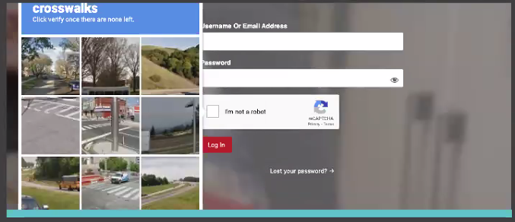
- Two types: invisible and checkbox
- Assesses how pieces of a website are regularly used to weed out suspicious users and bots
- Based on how user behaves on a website, a risk score between 0 (bad traffic) and 1 (good traffic) is created.
- Two-Factor Authentication (2FA)
- Email code sent is unique for that account and time sensitive (5 minutes)
- To hack into an account, hacker would need to have a username or email, current password, and access to the email account.
- Future options: SMS/Text, time-based one-time password (TOTP), one touch sign-on, magic link, single sign-on (SSO)
- Nonces
- A number used once to verify the form submission is from the same user that loaded the page.
- Nonces is a grouping of random characters randomly generated (i.e. 39a650fbec)
- Same nonce could possibly be used twice or more eventually but would not be the same for multiple accounts at the same time (holds for 12 hours)
Question: Does that mean that if I travel with my computer outside of it's usual area that I could get kicked out of iUnite? (Nonces) Ryan: By changing location it may just spit you out and ask you to relog in.
- Access Permissions – checking if you are allowed to access a page (user role checked, page/form access is checked, data access is checked before loading, DB Table access checked again before database tables are displayed)
- Data Sanatization: converts all submitted data to strings (text), checks for and removes code snippets (these are typically in the format of: <script>var code = something;</script>, files are scanned during upload for potential malicious code, suspicious file data, and file type mismatches (i.e. uploaded as a .pdf, but is really a .exe file).

- Scans, Alerts and Monitoring
- Three scans we have going on all the time ongoing: Malware and hack scanning, DNS Scanning, File integrity. If you have ever seen a site that suddenly redirects you or has a ton of adds, that is the type of hack that is often used to hurt companies and to try to send you to a phishing page. These scans prevent this from happening.
- Alerts happen when: user account changes happen, website changes, security events (i.e. unauthorized form submissions) and these are monitored.
- Monitoring: Blacklist monitoring, security logging – logins, failed login attempts, form submissions/actions taken, user account changes (add/edit/delete), password reset attempts.

