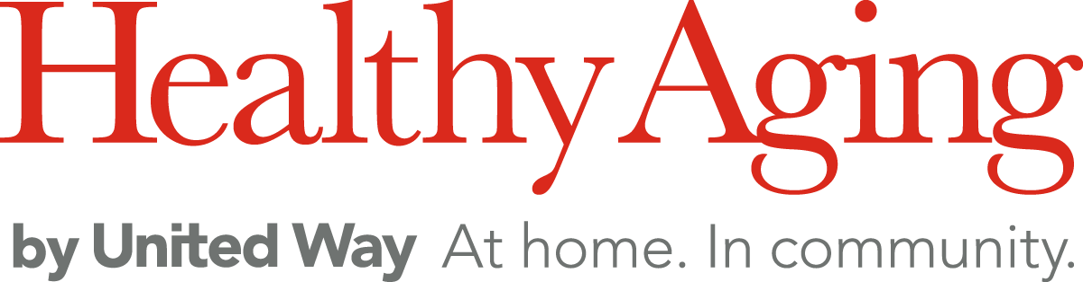

Name: ______________________________________ Date: _________________

Healthy Aging by United Way media release and consent form
I hereby irrevocably consent to being interviewed, photographed, video-taped, or otherwise recorded, whether by digital or other means, by or for Healthy Aging by United Way (“HAUW”) and/or its affiliates, with the understanding that such interviews, photographs, video-tapes or other recordings (the “Recordings”) may be used for publicity and/or fundraising purposes by HAUW and/or its affiliates now or in the future without further consideration or compensation to me and without any ownership in the Recordings being conferred upon me. I consent to the use of my full name in connection with the Recordings.

I hereby assign to HAUW and/or its affiliates, any right, title and interest I have or may have with respect to the Recordings and, for certainty, hereby grant to HAUW and/or its affiliates the right to reproduce, use, exhibit, broadcast, distribute and create derivative works of the Recordings. This grant includes, without limitation, the right to use the Recordings in any way HAUW and/or its affiliates, in their sole discretion, deems fit in connection with events, public service announcements, and/or promotions. Such authorized use of the Recordings includes, without limitation, television broadcast, webcast, illustration, promotion, advertising or publication, whether in print or electronic/online form, and includes without limitation use in connection with social media websites and applications. Furthermore, I also understand that HAUW and/or its affiliates are under no obligation to use the Recordings in the manners described herein.

I hereby acknowledge and understand that the Internet is not a secure medium, that any material posted on the Internet is accessible to anyone with access to a computer and suitable connection, and that while HAUW and its affiliates have made every reasonable effort to secure the United Way of the Lower Mainland (UWLM) website and/or social media sites and/or affiliate websites and/or social media sites, HAUW cannot absolutely guarantee privacy or control access to the UWLM website, its affiliates’ websites, or to other online locations where the Recordings may be displayed or posted.

I understand and accept that I hereby release and forever discharge HAUW, affiliated, member or related organizations and their respective officers, employees and volunteers of and from any and all liabilities, demands, debts, actions, and causes of action whatsoever which I at any time had or in the future may have as a result of my appearance or participation in the Recordings.

I certify that my organization’s participation in the Recordings is voluntary and that I enter into this Release and Consent on the behalf of my organization, as applicable.

Signature:

