These messages are designed to provide protective and preventive behaviours for people in BC to support them in staying safer during extreme heat emergencies by reducing modifiable risks. Organizations may add their own links to regional specific content or use ours. Graphic use at the discretion of organization.
Instructions for posting
- Copy-and-paste the content below in a new social media post
- Add links to resources and supports (see helpful links below), photos and hashtags specific to your community
- Check links before posting

Translations:
Translations are available in French, Simplified Chinese, Punjabi and Farsi.
Post Copy Translations: | Graphic Translations:  https://spaces.hightail.com/receive/oHhY2h3Dfe  (For access after September 1, 2022, email contact above)

Helpful Links:
Main Resource links | Additional Resources
- Extreme Heat Preparedness Guide  - Beat The Heat  - Heat-related Illness (HealthLinkBC File #35)  - Wildfires and Your Health  - Your Health This Summer | - Emergency First Aid for Heatstroke  - Heatstroke: Emergency Symptoms  - Heatstroke Prevention: What to Wear  - Sun Safety for Children (HealthLinkBC File #26)  - Ultraviolet Radiation (HealthLinkBC File #11)  - Heat Rash  - Heat Syncope (Fainting)  - Medicines That Increase the Chance for a Heat-Related Illness  - Prickly Heat Rash  - Sunburn  - Quick Tips: Staying Active in Hot Weather

MESSAGING:

 | TIMING | MESSAGE | GRAPHIC TEXT | GRAPHIC | EXPLANATION & ADDITIONAL INFO
 | BEFORE | Heat illnesses and deaths are preventable.  Find ways to prevent heat illness before it gets hot out <LINK> | HEAT RELATED ILLNESS IS PREVENTABLE | 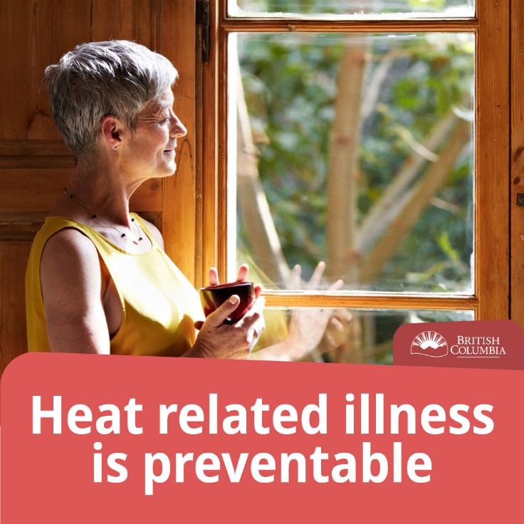 | This message empowers the reader. It reduces barriers to action.
 | BEFORE | Find ways to keep cool before the hot weather starts.  If you have an air conditioner, make sure it works properly. If you have ceiling fans or other fans, they can bring cooler air in from outside, but may not help at very hot temperatures. Fans cannot effectively reduce body temperatures or prevent heat-related illness in people at risk.  Find an air-conditioned spot close by where you can cool off for a few hours on very hot days. This will help you cope with the heat.  Use The Extreme Heat Preparedness Guide to make sure you’re ready.  <LINK> |  | 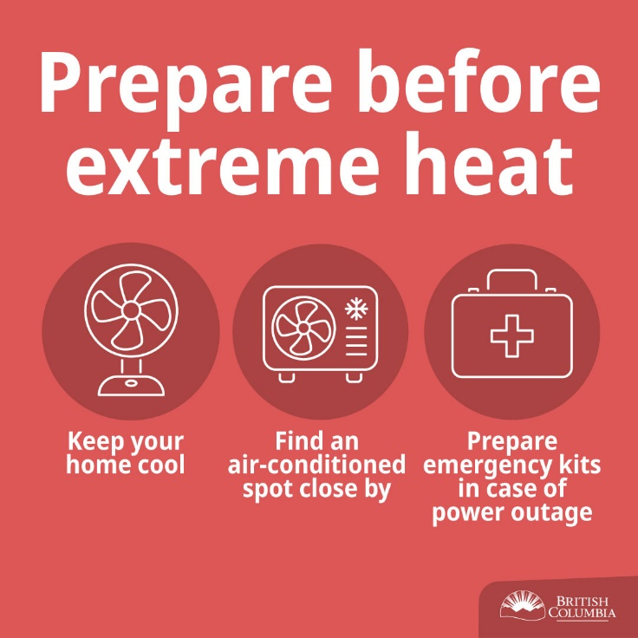
 | BEFORE | Be prepared to leave your home during an extreme heat emergency.  If you are at risk and you live in a building or residence that gets very hot, with sustained inside temperatures of 31°C (87.8°F) or higher, plan to go elsewhere.  Consider staying with friends or family that have air conditioning or cooler spaces. Alternatively, identify places in your community you can visit to get cool such as:  - movie theatres  - religious centres  - parks and other shaded green spaces  - libraries  - community centres  - shopping malls  You can also contact your First Nation or local government to find out if cooling centres will be available in your area.  Plan ahead with the Extreme Heat Preparedness Guide. <LINK> |  | 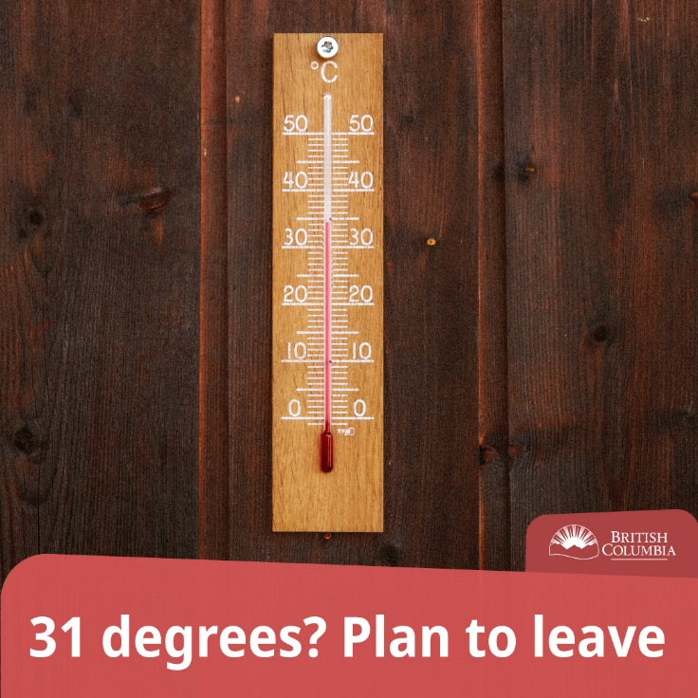
 | BEFORE | Extreme heat can put everyone at risk from heat illnesses, but health risks are greatest for:  - seniors aged 65 years or older  - people who live alone  - people with pre-existing health conditions such as diabetes, heart disease or respiratory disease  - people with limited mobility  - people with mental illness such as schizophrenia, depression, or anxiety  - people with substance use disorders  - people who are marginally housed  - people who work in hot environments  - people who are pregnant  - infants and young children  If you have family or friends at a higher risk from extreme heat, help them plan ahead with the Extreme Heat Preparedness Guide. <LINK> |  | 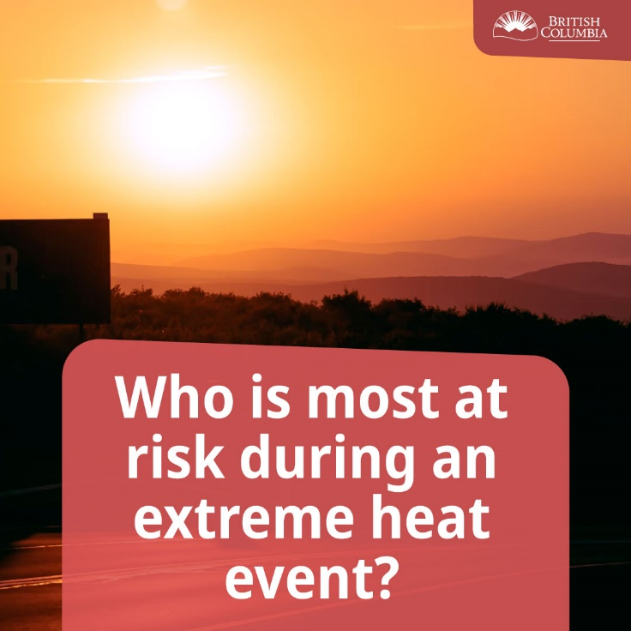 | See characteristics above
 | BEFORE | Have you thought about how you’ll prepare for extreme heat in BC this year?  Arrange for regular visits by family members, neighbours or friends during very hot days. Visitors can help identify signs of heat illness that could be missed over the phone.  If you live in a building or residence that gets very hot, with sustained inside temperatures of 31°C (87.8°F) or higher, plan to go elsewhere during an extreme heat emergency. It could be a cooling centre, or a mall, library, recreation centre, friend’s house, place of worship, or grocery store.  TIP! Keep a digital thermometer so you know when your home is getting too hot.  Use the Extreme Heat Preparedness Guide to get you ready. <LINK> |  | 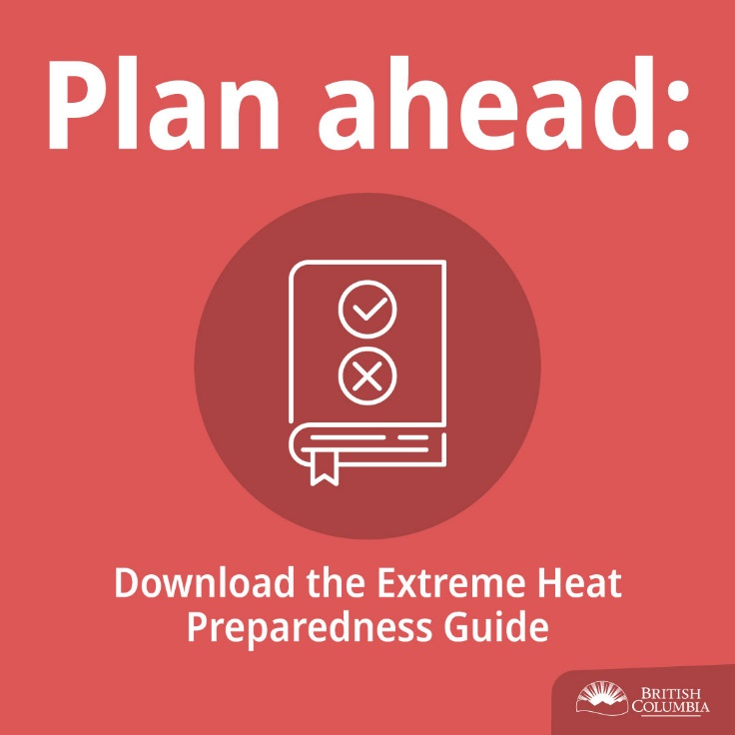 | Importance of visiting - Visitors can help identify signs of heat illness that could be missed over the telephone. Checking with a telephone call is sufficient only for people who have excellent self-care ability.  Frequency of visits - It is essential to use careful judgment of a person's ability for self-care and past experiences in hot environments when determining how often to visit the person under your care.
 | BEFORE | If you use regular medications, illicit drugs, or have a health condition, ask your doctor or pharmacist if it increases your health risk in the heat and follow their recommendations.  You can also call 8-1-1 and speak to a pharmacist for free from 5pm – 9am  Learn more about extreme heat in BC <LINK> | MEDICATIONS, ILLICIT DRUGS AND HEALTH CONDITIONS CAN INCREASE YOUR RISK DURING EXTREME HEAT | 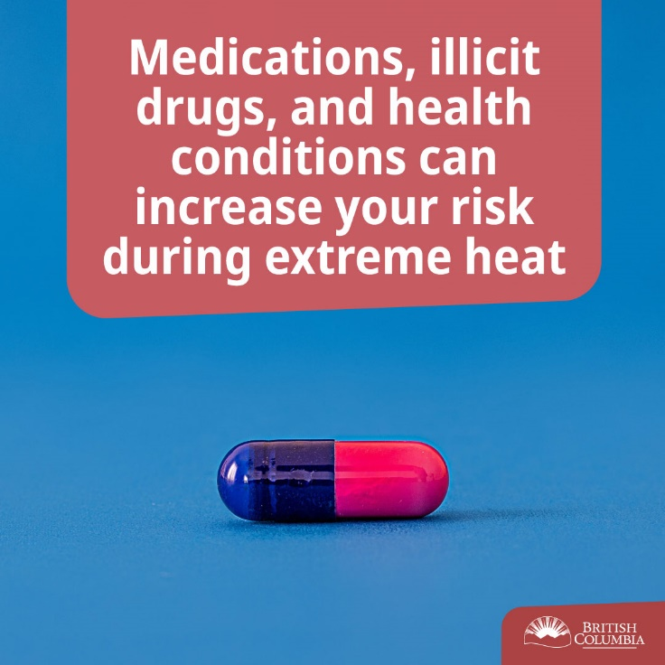 | Some drugs interfere with the body's ability to maintain normal body temperature. Sensitivity can vary widely, so people should be encouraged to seek advice from their doctors and pharmacists.
 | BEFORE  DURING | Did you know?  Your body isn't used to extreme heat at the beginning of the summer. If you're physically active, you're also not used to extreme heat if you don't exercise regularly during hot weather.  Learn more about extreme heat in BC <LINK> | LOWER YOUR ACTIVITY LEVELS DURING EXTREME HEAT | 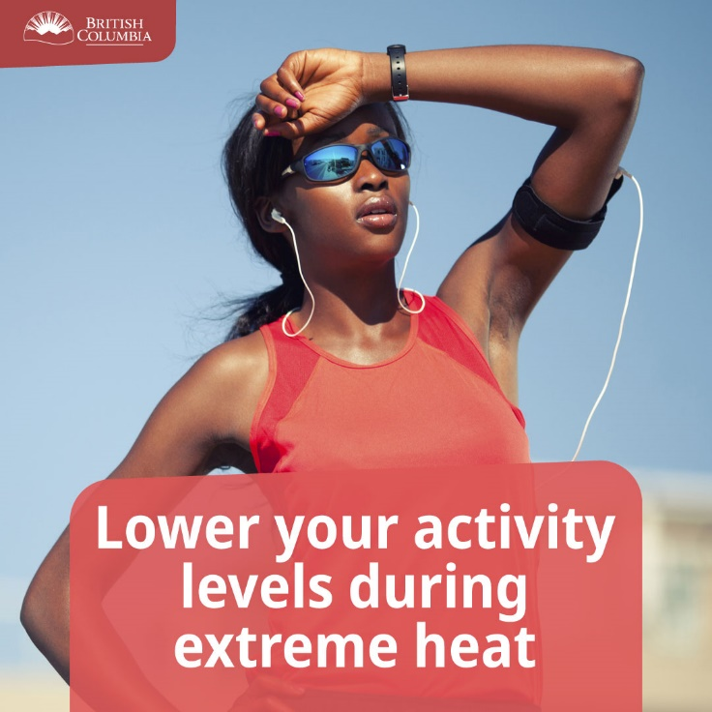 | Acclimatization - Exposure to outdoor temperatures in the summer helps to prepare a healthy person's body for the heat through acclimatization and may reduce the probability of heat illnesses. Acclimatization takes time and will depend on individual characteristics. Guidelines for healthy people who exercise or work in the heat indicate that it requires 10 to 14 days of exposure to hot temperatures for the body to adapt. Consequently, even for healthy people strenuous activities in the heat could be dangerous, especially early in the heat season.
 | BEFORE  DURING | Did you know? For healthy people who need to work or exercise, it takes 10 to 14 days of exposure to hot temperatures for the body to adapt.  Lower your activity level and avoid strenuous activity. If you must do errands or plan to exercise, do it early or late in the day when it is generally cooler.  It’s safest to limit your outdoor activity during extreme heat.  Find out more <LINK> |  | 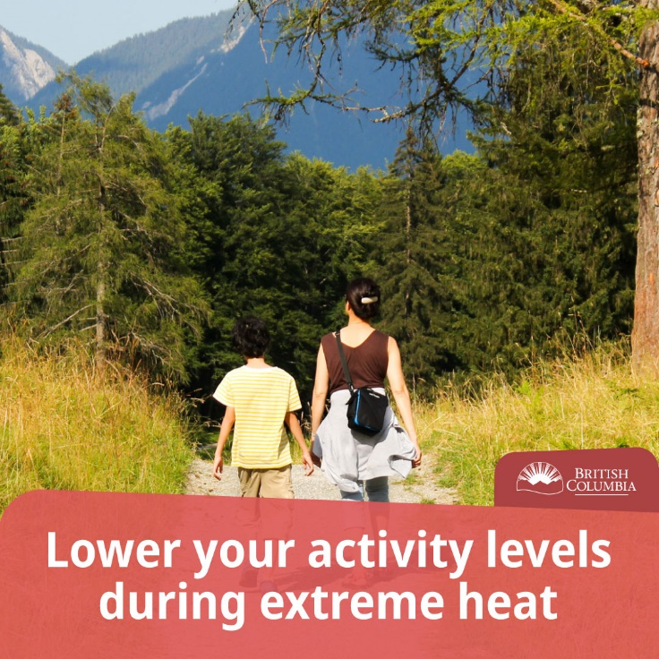
 | DURING | People who work outdoors may be more exposed to high temperatures and sun.  If you feel faint or weak, STOP all activity and get to a cool place.  Take steps to try and keep cooler and more comfortable by doing these things frequently:  - cooling down hands and arms with cool water  - seek shade  - take breaks  - drink water (even if you don’t feel thirsty)  Find more tips <LINK> | PEOPLE WHO WORK OUTDOORS MAY BE MORE EXPOSED TO HEAT AND SUN. TKE STEPS TO STAY COOL | 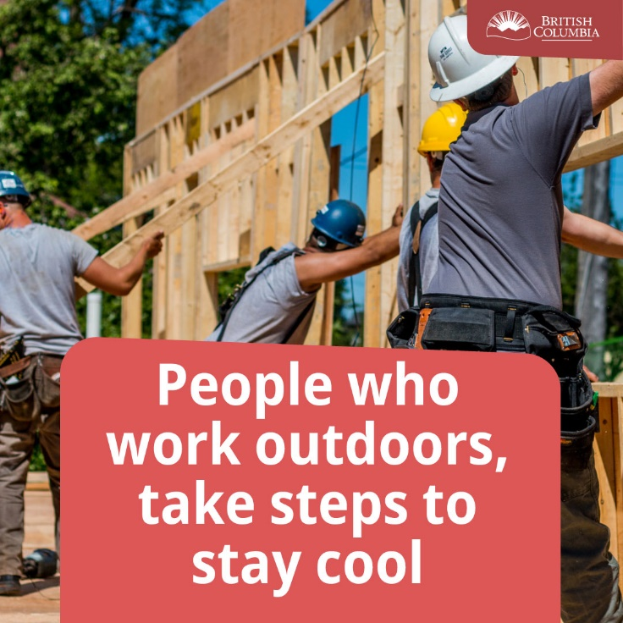 | Cooling hands and forearms - Cooling a person's hands and forearms can improve athletic and occupational performance and comfort while reducing heat strain
 | DURING | Immediate actions need to be taken when signs of heat illness are seen. If not treated immediately, they may result in a life-threatening condition such as heat stroke.  Heat illnesses include heat stroke, heat exhaustion, heat fainting, heat edema (swelling of hands, feet and ankles), heat rash and heat cramps (muscle cramps).  Watch for symptoms of heat illness, which include:  - dizziness  - nausea or vomiting  - headache  - rapid breathing and heartbeat  - extreme thirst  - decreased urination with unusually dark yellow urine  If you experience any of these symptoms during extreme heat, immediately move to a cool place, start cooling down, and drink liquids. Water is best.  Call 911 immediately if your symptoms are severe.  Ways to cool down:  - moving to a cooler place, if you can;  - submerging yourself or the person you’re helping in cool water;  - applying damp cloths or cold water to large areas of the skin; and  - fanning yourself or the person as much as possible.  Find out more about what to do to keep you and the people you care about safer during very hot days. <LINK> |  | 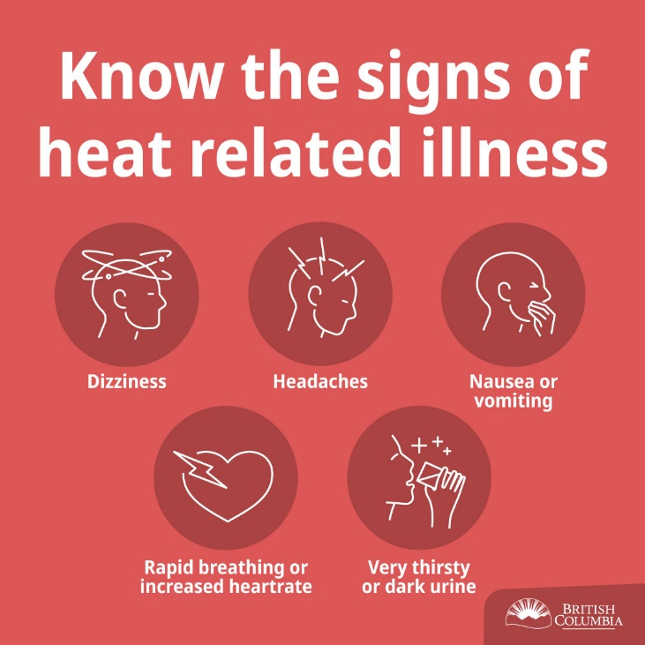 | Urgency of the situation - Immediate actions need to be taken when signs of heat illness are seen. If not treated immediately, they may result in a life-threatening condition such as heat stroke. This urgency should be highlighted in the message.  First aid advice - When symptoms of heat exhaustion are seen, the most effective treatment is to move the person to a cool place. The message should focus on a cool place rather than an air-conditioned place (e.g. shopping mall, public building). This will °C/9°F cooler than the surrounding area.
 | DURING | Heat stroke is a medical emergency! Call 911 or your local emergency number immediately if you are caring for someone, such as a neighbour, who is unconscious, fainting, or confused.  While waiting for help - cool the person right away by:  - moving them to a cool place, if you can;  - submerging in water or applying cold water to large areas of the skin or clothing; and  - fanning the person as much as possible.  Read more about heat stroke and heat illness <LINK> | HEAT STROKE IS AN EMERGENCY | 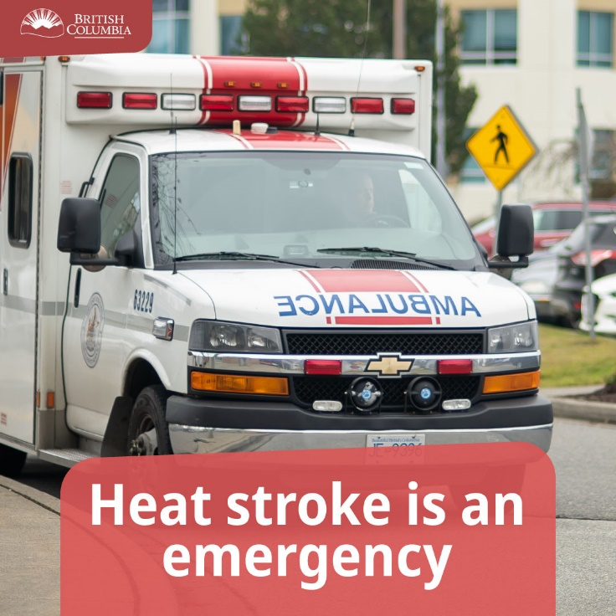 | Medical emergency - Heat stroke is a medical emergency and requires immediate medical attention, as the mortality rate can be high.https://www.canada.ca/en/health-canada/services/environmental-workplace-health/reports-publications/climate-change-health/communicating-health-risks-extreme-heat-events-toolkit-public-health-emergency-management-officials-health-canada-2011.html - fn32 Emphasize the immediate need to call 911 or a local emergency number, which should be included in the message.  Sweating - Sweating is not a good indicator of heat stroke for the general public because there are two types of heat stroke - classic (accompanied by little or no sweating, usually occurring in children, those who are chronically ill and older adults) and exertional (accompanied by an increase in body temperature because of strenuous exercise or occupational exposure along with environmental heat, and where sweating is usually present).  High body temperature - Core body temperature over 40°C/104°F is indicative of heat stroke. However, to get an accurate reading you need to use a rectal thermometer, which may not be available or convenient. Therefore, "high body temperature" was chosen to describe this sign of heat stroke since immediate action is required.  Cooling advice - Full body submersion in cool water is the fastest method to treat exercise-induced heat stroke (effective among young people, military personnel and athletes with exertional-related heat stroke). However, it is mainly applicable in a clinical setting. In other settings, cool the person by applying cold water to large areas of the skin or clothing and fan them as much as possible, keeping in mind that cooling larger areas will improve efficiency.
 | DURING | What can I do to make sure people I care about are safe during extremely hot days?  Frequently visit neighbours, friends and older family members, especially those who are chronically ill, to make sure that they are cool and hydrated.  If you or someone you know is at higher risk, offer to be their heat buddy – someone who will check in and offer help during extreme heat emergencies.  When you check in, make sure they have a cooler space to sleep in or help them rearrange to sleep in the coolest part of their home.  If you know someone who might be at a higher risk for heat illness, check in regularly. Find more ways to help <LINK> |  | 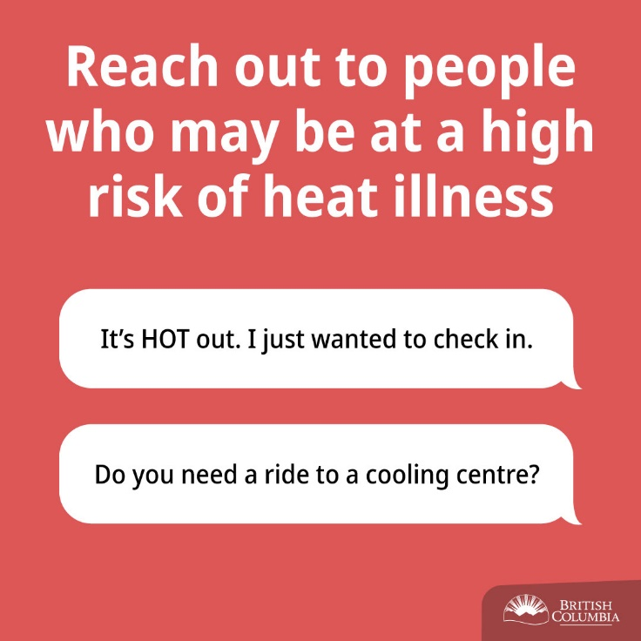
 | DURING | What should I do if there is wildfire smoke during an extreme heat emergency?  Prioritize cooling down. If you live in an area experiencing extreme heat and poor air quality, first find ways to keep cool. Heat illness can come on fast.  It’s best if you can find a cooler place with cleaner air. You may need to leave your home and find a cooling centre or somewhere like a mall, library, place of worship, or recreation centre where you can cool down with cleaner air.  You can check the air quality index <LINK> to see what the air quality is in your region. | WILDFIRE SMOKE & EXTREME HEAT EMERGENCY.  PRIORITIZE COOLING AND PREPARE TO LEAVE. | 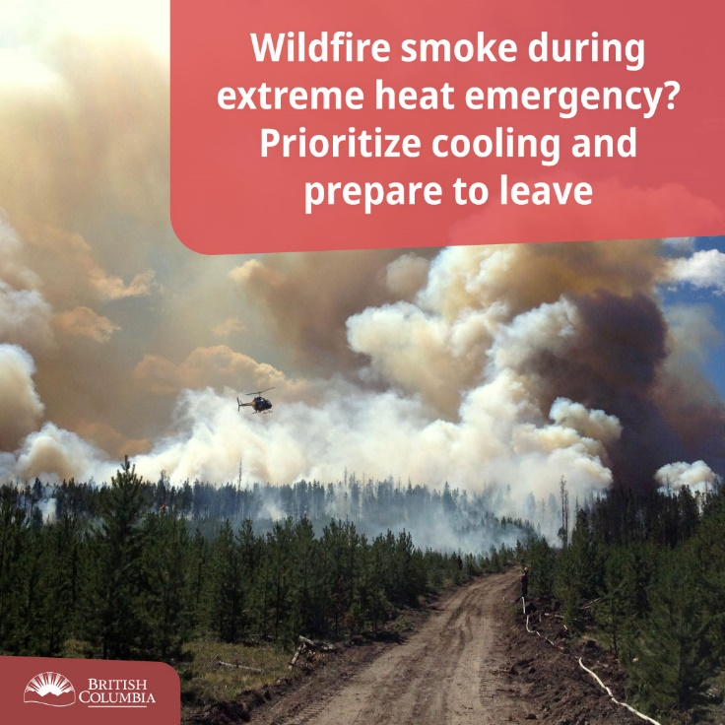 | When an extreme heat event and a poor air quality event occur at the same time, cooling should be prioritized.
 | BEFORE | Prepare for extreme heat ahead of time by making ice and prepare jugs of cool water.  Drink plenty of cool liquids, especially water, before you feel thirsty to decrease your risk of dehydration. Thirst is not a good indicator of dehydration.  Be ready for extreme heat by using the Extreme Heat Preparedness Guide <LINK> | PREPARE WATER AND ICE. DRINK WATER EVEN IF YOU’RE NOT THIRSTY. | 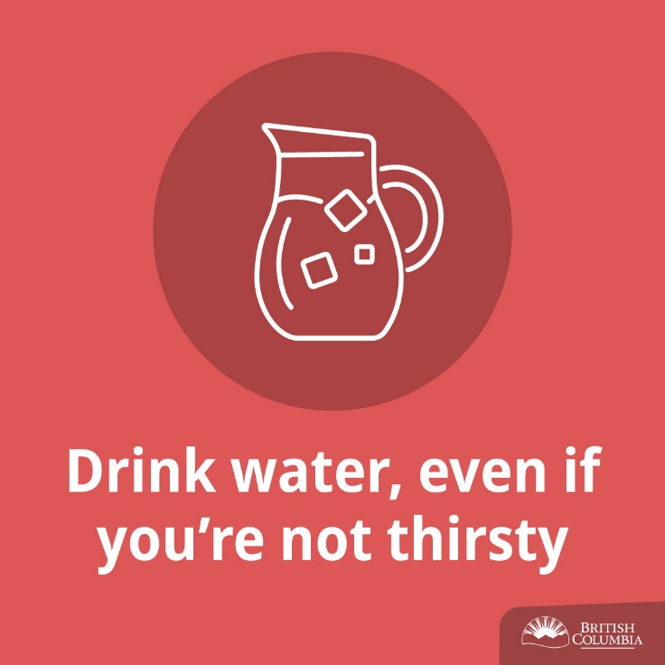 | Drink "before you feel thirsty" - Many people, especially older adults, may be in a state of chronic dehydration because of a reduced ability to feel thirst, the body's reduced ability to react to dehydration and concern over frequent urination. By the time a person feels thirst, they have already lost about 2% of their body water and dehydration has occurred. One method of reminding people to drink water is by advising them to leave a colourful glass by the sink and to drink from it after every hand washing.  Volume of water - Individuals should take personal responsibility for keeping hydrated. People gain water from food and liquid intake, and lose water through urination, sweating and normal metabolic processes. Everyone has different water needs, depending on their activity level, diet, exposure to heat, perspiration rate and sodium concentration in sweat. Canada's Food Guide recommends drinking "more water in hot weather or when you are very active."  - People who eat very little, such as older adults, may not be getting sufficient amounts of water and may need to drink more. However, it is important not to over-hydrate as it may lead to a medical emergency (hyponatremia) caused by low plasma salt levels.  - Research has also shown that people who do not take part in intense activity do not need to take supplements, such as salt tablets, to maintain proper plasma salt levels.  Water versus juice or sports drinks - Water is the best hydrating liquid. Sports drinks and juices are popular but are also expensive. Considering the large quantities of juice or sports drinks that need to be consumed to stay properly hydrated in the heat, consumption of these liquids could be dangerous for diabetics. On the other hand, as our society has developed a taste for juices and sodas, flavouring water with natural fruit juice may make it more appealing.  Caffeinated beverages - Caffeine is a diuretic that increases urination. Regular caffeine users are adjusted to the effect of caffeine, minimizing its diuretic properties. Therefore, people may continue to drink caffeinated beverages during extreme heat, but should not increase consumption during this time.  Cool liquids - Research suggests that people will not drink enough water unless it has been cooled (21-24°C/70-65°F).  Fruits and vegetables - Fruits and vegetables have high water content and are a great snack to increase daily water consumption.
 | DURING | Drink plenty of cool liquids (especially water) before you feel thirsty to decrease your risk of dehydration (not having enough fluids in your body). Thirst is not a good indicator of dehydration.  - If you eat less, you may need to drink more water.  - Drink water before, during and after physical activity.  - Remind yourself to drink water by leaving a glass by the sink.  - Eat more fruits and vegetables as they have a high water content.  Find more ways to keep cool and stay safe during extremely hot days <LINK> |  | 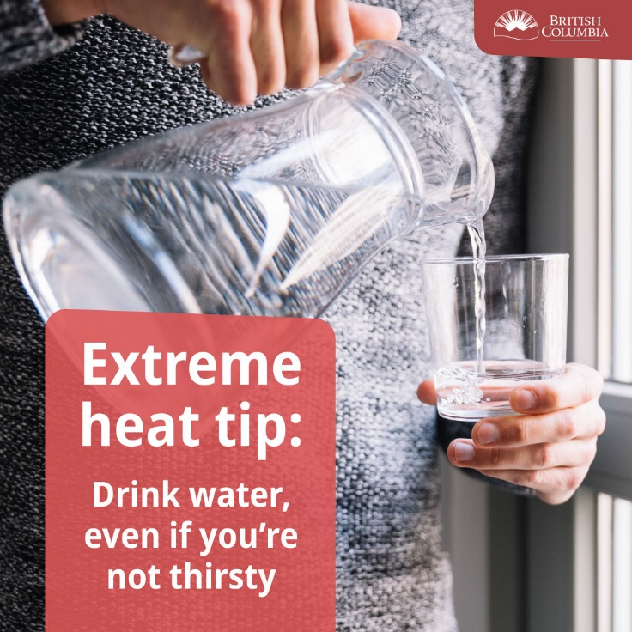
 | DURING | Staying hydrated during hot days is important. Don’t wait until you feel thirsty.  Leave a bright drinking cup by the sink, every time you wash your hands, have a drink. Or set a timer on your phone to remind you to drink water. This can help ensure you don’t get dehydrated.  Learn more about preventing heat illness <LINK> |  | 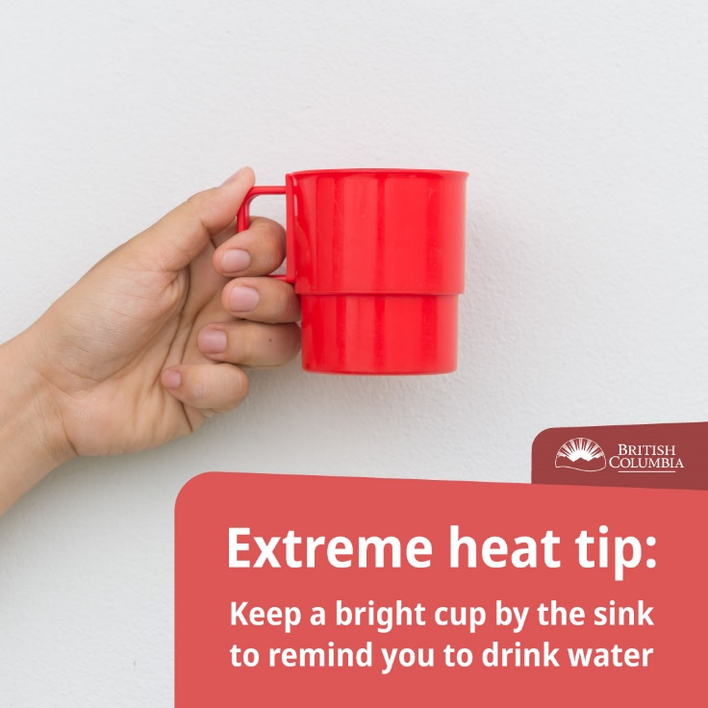
 | DURING | Reschedule or plan outdoor activities during cooler parts of the day.  Outdoor temperatures usually peak around 5 p.m. in BC, but indoor temperatures usually peak a few hours later.  Remember, heat stroke can come on fast. <LINK> | PLAN OUTDOOR ACTIVITIES DURING COOLER PARTS OF THE DAY. | 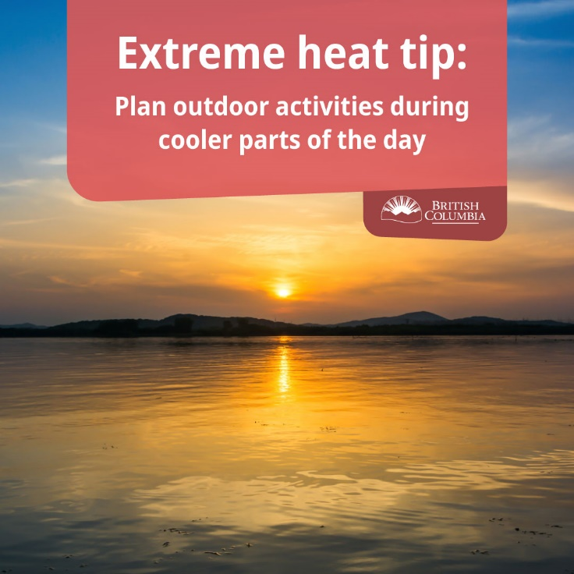 | Defining "cooler parts of the day" - Every region has its own micro-climate. Depending on the location of a person's residence, their body could get a heat load from direct sunlight during the day or from pavement and buildings even after the sun sets. It is important to let people decide which time is cooler and more comfortable for outdoor activities.  Give options - For those who may want to participate in outdoor activities, offer safer options such as:  - rescheduling outdoor activities to a cooler part of the day or another day;  - exercising in an air-conditioned place rather than heading outdoors;  - choosing a cooler outdoor location such as a tree-shaded area away from high traffic to avoid high levels of air pollution; or  - if one of these options is not possible, the activity duration and intensity should be reduced.  West Nile virus - Mosquitoes can transmit West Nile virus and are most active during cooler parts of the day. To minimize the possibility of infection, include the following West Nile virus safety tip from Health Canada :  - If you are in an area where mosquitoes are active, protect yourself with insect repellent and follow the manufacturer's directions.  Encourage the audience to move around - Moving around may actually reduce the possibility of fainting in the heat. People who sit or stand for an extended period of time may be at greater risk during extreme heat events.
 | DURING | Never leave people or pets in your care inside a parked vehicle or in direct sunlight.  The temperature inside a car can heat up to dangerous levels very fast.  When the outside air temperature is 23°C/73°F, the temperatures inside a car can be more than 50°C/122°F.  Learn more about extreme heat in BC <LINK> |  | 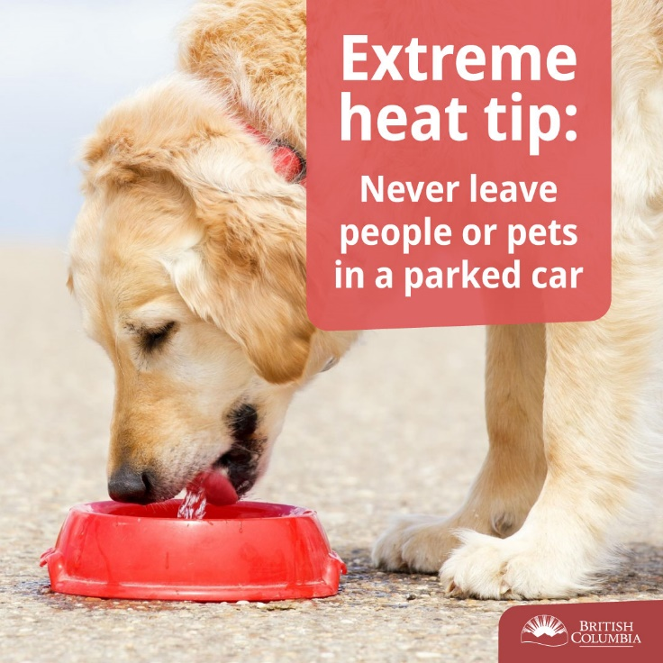 | Temperature inside a vehicle could get very dangerous - When the outside air temperature is 23°C/73°F, the temperatures inside a vehicle can be extremely dangerous - more than 50°C/122°F
 | DURING | Take a break from the heat by spending a few hours in a cool place.  It could be a tree-shaded area, swimming facility or an air-conditioned spot such as a public building, shopping mall, grocery store, place of worship or public library.  <REGIONAL RESOURCES OF COOLING CENTRES? TRANSIT OPTIONS FOR FREE RIDES?> |  | 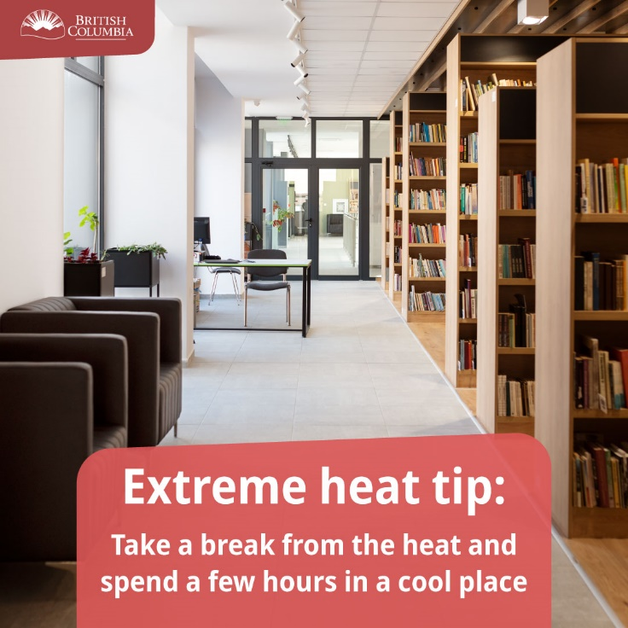
 | BEFORE  DURING | Did you know? Keeping the sun out of your home can decrease indoor temperatures by 2°C to 3°C.  When the sun shines through windows it causes the indoor environment to heat up, like a greenhouse.  Close blinds or use other window coverings to keep the sun out and temperature inside a bit lower.  Find more ways to lower your risk during extremely hot days <LINK> |  | 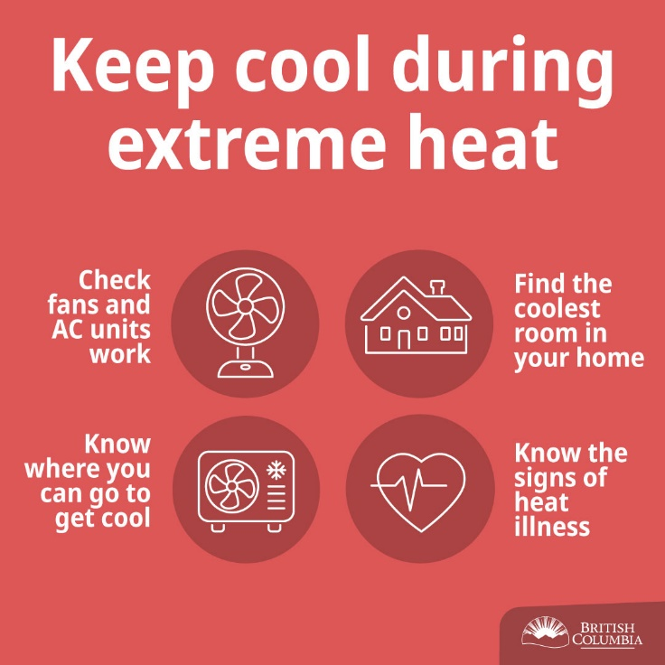 | "Greenhouse effect" - Allowing the sun to beam through the windows will increase your indoor temperature due to the "greenhouse effect" and will result in trapping hot air in the home. Installing and closing awnings or shutters is very effective at keeping the heat outside, since the sun's rays will be blocked before they reach the window.  Plan for the future - Planting a broadleaf tree on the side of the house where the sun hits during the hottest part of the day will provide shade during the summer months and shelter the house from radiant heat.
 | BEFORE  DURING | TIPS to keep your home cool  - Make meals that don't need to be cooked in an oven.  - Block the sun by closing awnings, curtains or blinds during the day.  - If possible, open your windows at night to let cooler air into your home and use fans to move cooler air through the home  - If you have an air conditioner with a thermostat, keep it set to the highest setting that is comfortable (26ºC/79ºF is a safe temperature). This will reduce your energy costs and provide you with needed relief. If you are using a portable or window air conditioner, cool only 1 room where you can go for heat relief.  Find more ways to lower your risk during extremely hot days <LINK> | TIPS TO KEEP YOUR HOME COOLER DURING AN EXTREME HEAT EMERGENCY. | 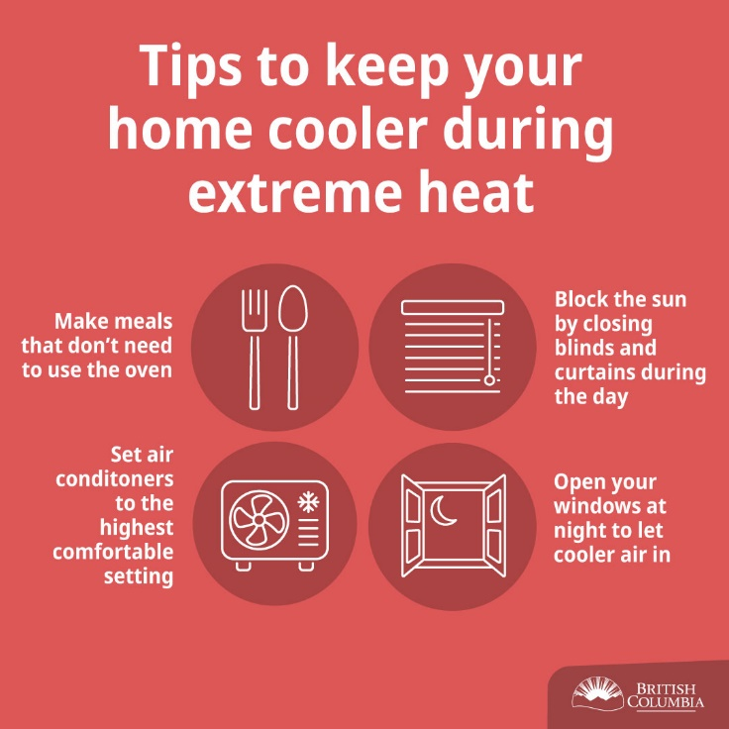 | Use of air conditioners during extreme heat events diminishes heat-health risks. However, air conditioners can use a lot of energy, give off greenhouse gases and may decrease acclimatization to heat. Therefore, public health information should highlight alternatives and educate about the most efficient use of air conditioners. Messages that suggest using air conditioners should include user guidelines such as:  - If you have an air conditioner, make sure it works properly before the hot weather starts.  - If you have an air conditioner with a thermostat, keep it set to the highest setting that is comfortable (somewhere between 22°C/72°F and 26°C/79°F), which will reduce your energy costs and provide you with needed relief.  - If you are using a window air conditioner, cool only one room where you can go for heat relief.
 | BEFORE | You can make sure you and your home are prepared for extreme heat.  Some areas of your residence may stay cooler than others. During an extreme heat emergency, you should prepare to stay in the coolest part of the residence where you can focus on keeping that one location cool.  Start by identifying a room that’s typically coolest and consider how you can modify the layout to support sleeping and day-to-day living for a short period of time.  Use The Extreme Heat Preparedness Guide to make sure you’re ready.  <LINK> |  | 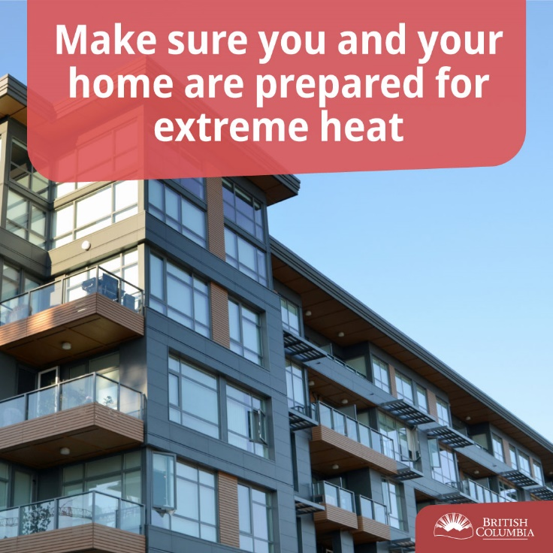 | Heat is made up of four main physical and environmental factors that contribute to the body's heat load: humidity, radiant load, temperature and wind speed. Direct sun exposure will increase the radiant load and total heat exposure. This is why shaded areas are cooler and wearing a wide-brimmed, breathable hat or using an umbrella in the sun is recommended.  Hats - Basic scientific principles, as well as designs that have evolved in hot climates, indicate that hats worn to protect against the sun's ultraviolet (UV) rays and sunburn should be:  - Wide-brimmed - Peaked baseball caps offer good protection to the nose, but not other areas of the face, ears and back of the neck. Hats with a wide brim (at least 7.5 cm/3 ins.) are necessary to provide adequate protection.  - Breathable - Breathable fabrics are practical for evaporative cooling and decreasing heat accumulation in the hat.  Umbrella - Using an umbrella to avoid sun (radiant load) exposure is ideal as it does not interfere with evaporative cooling and provides a lot of shade.  Sunburn - UV exposure could result in sunburn. Sunburned skin loses its sweating efficiency, which impairs the ability of the body to regulate its temperature.  Sun safety - If sun exposure is unavoidable, recommend the use of a sunscreen lotion that is SPF 15 or higher and that users follow the manufacturer's directions for safe use. Remind your audience that sunscreen and insect repellents can be safely used together, and that they should apply the sunscreen first, then the insect repellent.
 | DURING | Avoid sun exposure. Shade yourself by wearing a wide-brimmed, breathable hat or using an umbrella. Pick clothing that is lightweight, light-coloured and loose fitting. Fabrics like cotton let the skin breathe, light coloured fabrics reflect light and heat, and loose clothing helps airflow. This will keep you cooler.  If you can’t avoid the sun, ensure you use a sunscreen SPF 30 or higher. Sunscreen and insect repellents can be safely used together, apply the sunscreen first, then the insect repellent.  Find out more <LINK> |  | 